EXPERIMENT 3

CREATE TABLE EMPLOYEE_63(
EMP_ID int,
EMP_name varchar(30),
Dept varchar(30),
Salary numeric(5,1),
primary key (EMP_ID));

output:
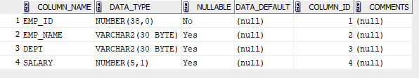
INSERT INTO EMPLOYEE_63 values(1,'David Smith','Marketing',7500);
INSERT INTO EMPLOYEE_63 values(2,'Olivia Johnson','HR',6800);
INSERT INTO EMPLOYEE_63 values(3,'Charles Brown','Sales',7200);
INSERT INTO EMPLOYEE_63 values(4,'Alice Miller','Production',6400);
INSERT INTO EMPLOYEE_63 values(5,’Oscar White’, ’ Marketing’,9000);
select *from EMPLOYEE_63;
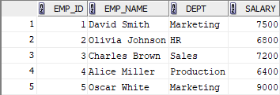

1)SELECT EMP_name FROM EMPLOYEE_63 WHERE Salary>7000;

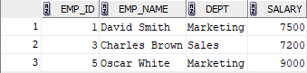

2)UPDATE EMPLOYEE_63 set Salary =8200 where EMP_name= 'David Smith';

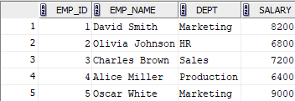

3) INSERT INTO EMPLOYEE_63 values(6,'Daniel Harris','production',6700);

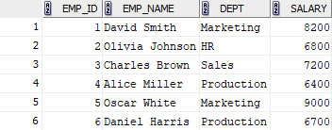

4) DELETE FROM EMPLOYEE_63 WHERE EMP_ID=3;
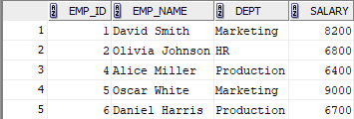

5)SELECT EMP_name from EMPLOYEE_63 where EMP_name not like 'D%' and EMP_name not like 'O%';

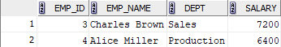

6) SELECT SUM(Salary),Dept FROM EMPLOYEE_63 group by Dept;

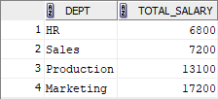

7) Update EMPLOYEE_63 set Salary = Salary+(Salary*0.05)where Dept='production';

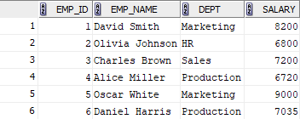

8)DELETE FROM EMPLOYEE_63 WHERE Salary <7000;

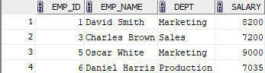

9)Select EMP_name,Salary FROM EMPLOYEE_63 where Salary=(select min(Salary)From EMPLOYEE_63);

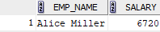

10) UPDATE EMPLOYEE_63 set Salary=8200 where Dept='Marketing';

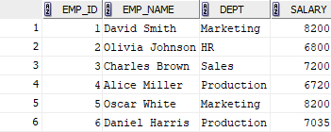

11) Select EMP_name from EMPLOYEE_63 where EMP_name like 'A%';

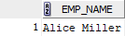

12) Select EMP_name from EMPLOYEE_63 where EMP_name like '%it';

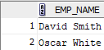

13) select upper(Dept) FROM EMPLOYEE_63;

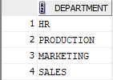

14) Select *from EMPLOYEE_63 where Dept like 'm_r%' and Dept like'%ket';

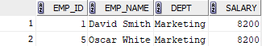

15) select distinct reverse(upper(Dept)) from EMPLOYEE_63;

